Paper title – Times New Roman, bold, 14, center

**Name Surname**1**, Name Surname**2

1 Name of Institution/Department, City, Country, e-mail

2 Name of Institution/Department, City, Country, e-mail

**Abstract**

Leave one empty line under the author(s) and write the abstract – 250-500 words; Font: Times New Roman, Size: 11 pt, Font style: Regular, Alignment: Justify; Line spacing: Single; Special/First Line: 1 cm.

**Keywords:** After the abstract enter up to 5 keywords

# Introduction

After the Keywords leave one empty line and start with a couple of sentences that introduce the topic.

# 1. Headline

Main text of the paper – Font: Times New Roman, Size: 12 pt; Line spacing: Single; Alignment: Justified, Special/First Line: 1 cm.Please note that the full paper should not exceed **8 pages** including text, figures, tables and references.

**Language**: Papers should be written in English Language.

**Font**: Times New Roman, Size 12, Colour Black.

**Page Setup**: Size: A4 paper, Portrait.

**Margins**: Left/Right 2.5 cm, Top 2.5 cm, Bottom 2.5 cm, Header/Footer 1 cm.

**Alignment**: Justify, Line spacing: Single, Paragraph Before 0pt, After 0pt.

# 2. Headline

**Harvard Referencing In-Text**: In-text references must be included following the use of a quote or paraphrase taken from another piece of work. Using an example author M. Moullin, this takes the form: Moullin (2004, p. 189) states.. Or (Moullin, 2004, p. 189)

When citing a source with two or three authors, state all surnames like so: Kennerley and Neely (2003, p. 189) states… Or (Kennerley and Neely, 2003, p. 189).

**Tables**: Table number should be positioned above the table – Font: Times New Roman, Size: 12 pt; Alignment: Right; On a new line the table title – Font: Times New Roman, Size: 12 pt; Line spacing: Single, Alignment: Center.

Table 1. Font: Times New Roman, Size: 12 pt; Alignment: Right.

Table title – Font: Times New Roman, Size: 12 pt; Alignment: Center

|  |  |  |  |
| --- | --- | --- | --- |
| **№** | **Column1** | **Column2** | **Column3** |
| 1 |  |  |  |
| 2 |  |  |  |
| 3 |  |  |  |

**Figures and images:**Should be inserted at the appropriate place within the text boundaries; the figure number and title should be positioned below the figures – Font: Times New Roman, Size: 12 pt; Line spacing: Single, Alignment: Center.

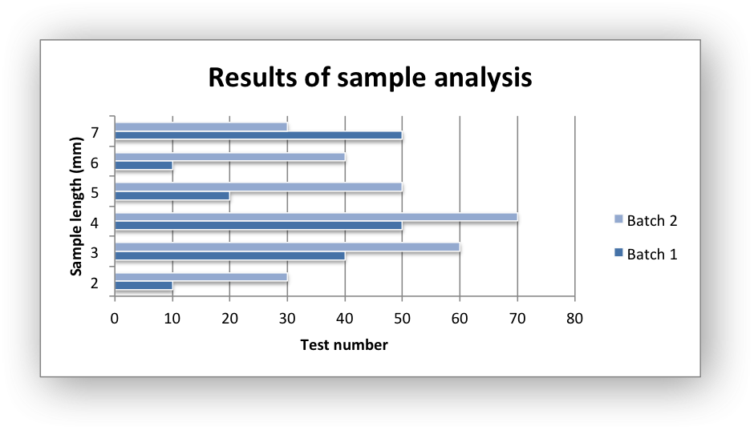

Figure 1. Font: Times New Roman, Size: 12 pt; Alignment: Center  
Source: Own Elaboration / Adapted by (Author, year) / Created by (Author, year)

**Equations**: Number equations consecutively. Be sure that the symbols in your equation have been defined before or immediately following the equation.

$α + β=γ$

  

# Conclusion

Summarize the results of the research/paper and write the conclusion with a few sentences here.

# References

1. BRADBURY, I., BOYLE, J. and MORSE, A. (2002) *Scientific Principle for Physical Geographers*. Harlow: Prentice Hall.
2. CAMPBELL, N. A et.al. (2008) *Biology*. 8th Ed. London: Pearson.
3. KENNERLEY, M. and NEELY, A. (2003) Measuring performance in a changing business environment*. International Journal of Operations and Production Management*. 23 (2). pp. 213-229.
4. MITCHELL, J., A. and Thomson, M. (2017) *A guide to citation*. 3rd Ed. London: London Publishing.
5. MOULLIN, M. (2004) Eight essentials of performance management. *International Journal of Health Care Quality Assurance*. [Online] 17 (3). pp. 110-112. Available from: http://www.emeraldinsight.com/ [Accessed 2/03/2019].
6. NEVILLE, C. (2010) *The Complete Guide to Referencing and Avoiding Plagiarism*. 2nd Ed. Maidenhead: Open University Press.